Loan default analysis

## Data importation

library(tidyverse)

## ── Attaching core tidyverse packages ──────────────────────── tidyverse 2.0.0 ──  
## ✔ dplyr 1.1.3 ✔ readr 2.1.4  
## ✔ forcats 1.0.0 ✔ stringr 1.5.0  
## ✔ ggplot2 3.4.4 ✔ tibble 3.2.1  
## ✔ lubridate 1.9.3 ✔ tidyr 1.3.0  
## ✔ purrr 1.0.2   
## ── Conflicts ────────────────────────────────────────── tidyverse_conflicts() ──  
## ✖ dplyr::filter() masks stats::filter()  
## ✖ dplyr::lag() masks stats::lag()  
## ℹ Use the conflicted package (<http://conflicted.r-lib.org/>) to force all conflicts to become errors

library(tidymodels)

## ── Attaching packages ────────────────────────────────────── tidymodels 1.1.1 ──  
## ✔ broom 1.0.5 ✔ rsample 1.2.0  
## ✔ dials 1.2.0 ✔ tune 1.1.2  
## ✔ infer 1.0.5 ✔ workflows 1.1.3  
## ✔ modeldata 1.2.0 ✔ workflowsets 1.0.1  
## ✔ parsnip 1.1.1 ✔ yardstick 1.2.0  
## ✔ recipes 1.0.8   
## ── Conflicts ───────────────────────────────────────── tidymodels_conflicts() ──  
## ✖ scales::discard() masks purrr::discard()  
## ✖ dplyr::filter() masks stats::filter()  
## ✖ recipes::fixed() masks stringr::fixed()  
## ✖ dplyr::lag() masks stats::lag()  
## ✖ yardstick::spec() masks readr::spec()  
## ✖ recipes::step() masks stats::step()  
## • Use tidymodels_prefer() to resolve common conflicts.

loans_df <- read_rds("C:/Users/Administrator/Desktop/loan_data.rds")  
loans_df<-data.frame(loans_df)  
head(loans_df)

## loan_default loan_amount installment interest_rate loan_purpose  
## 1 yes 35000 927.29 17.25 small_business  
## 2 yes 10000 259.58 11.50 small_business  
## 3 no 28800 941.65 8.97 debt_consolidation  
## 4 yes 4475 164.99 10.00 medical  
## 5 no 3600 110.70 9.72 medical  
## 6 yes 12800 389.10 20.00 medical  
## application_type term homeownership annual_income current_job_years  
## 1 individual five_year rent 104660 2  
## 2 individual five_year mortgage 57000 10  
## 3 individual three_year rent 160000 10  
## 4 individual three_year rent 37000 1  
## 5 individual three_year mortgage 72000 4  
## 6 individual five_year rent 73000 10  
## debt_to_income total_credit_lines years_credit_history missed_payment_2_yr  
## 1 29.41 27 15 no  
## 2 23.79 14 4 no  
## 3 5.96 35 17 no  
## 4 13.82 7 5 no  
## 5 22.68 35 11 no  
## 6 30.94 57 14 no  
## history_bankruptcy history_tax_liens  
## 1 no no  
## 2 no no  
## 3 yes no  
## 4 no no  
## 5 no no  
## 6 no no

# Data analysis

## Question 1: Is there a significant difference in the loan amount between borrowers who defaulted on their loans and those who did not?

## Summary dataframe showing Average loan amount by loan default

plotdata <- loans_df %>%  
group_by(loan_default) %>%  
summarize(mean_loan_amount = mean(loan_amount))  
plotdata

## # A tibble: 2 × 2  
## loan_default mean_loan_amount  
## <fct> <dbl>  
## 1 yes 17448.  
## 2 no 16245.

## Bar plot showing Average loan amount by loan default

ggplot(plotdata,  
aes(x = loan_default,  
y = mean_loan_amount)) +  
geom_bar(stat = "identity", fill="blue")+  
 labs(title = "Average loan amount by loan default")

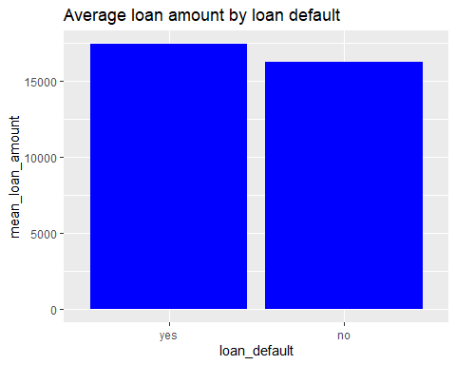

Figure 1

Answer: Based on the results from the bar graph above and the summary data frame above, there is a difference in the loan amount between borrowers who defaulted on their loans and those who did not. The average amount taken by those who defaulted on payment was 17,447.53, while the average amount for those who did not default on loan payment was 16,245.21. Those who took bigger loans were more likely to default.

## Question 2: Does the interest rate offered to borrowers have an impact on their likelihood of defaulting on loan payments?

## Summary dataframe showing Interest rate distribution by likelihood of loan defaulting

plotdata <- loans_df %>%  
group_by(loan_default) %>%  
summarize(mean_interest_rate = mean(interest_rate))  
plotdata

## # A tibble: 2 × 2  
## loan_default mean_interest_rate  
## <fct> <dbl>  
## 1 yes 14.9   
## 2 no 9.30

## Boxplot showing Interest rate distribution by likelihood of loan defaulting

ggplot(loans_df, aes(x = loan_default, y = interest_rate)) +  
geom_boxplot(notch = TRUE,  
fill = "cornflowerblue",  
alpha = .7) +  
labs(title = "Interest rate distribution by likelihood of loan defaulting")

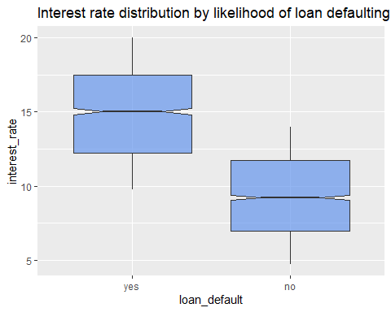

Figure 2

Answer: Yes, the interest rate offered to borrowers have an impact on their likelihood of defaulting on loan payments. The average interest rate among those who defaulted on loan payment was 14.89% while the average interest rate among those who did not default was 9.30%.

## Question 3: Is there an association between the loan term and the likelihood of loan default?

## Grouped bar chart showing Lona Default By Loan Term

# grouped bar plot  
ggplot(loans_df,  
aes(x = term,  
fill = loan_default)) +  
geom_bar(position = "dodge")+  
 labs(title = "Lona Default By Loan Term", x="Loan Term", y="Frequency")

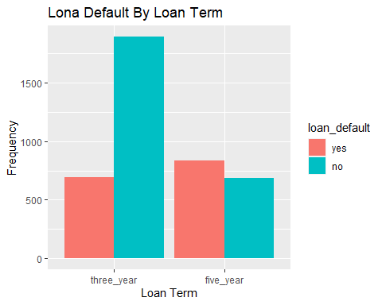

Figure 3

Answer: Yes, there is an association between the loan term and the likelihood of loan default. The results from Figure 3 above show that the likelihood of loan default was higher among five-year loan terms compared to three-year loan terms. The rate of default in the five-year loan term was higher than the rate of payment within the five-year loan term.

## Question 4: Is there a relationship between defaulting on the loan and loan purpose?

## Grouped bar chart showing the relationship between defaulting on the loan and loan purpose

# grouped bar plot  
ggplot(loans_df,  
aes(x = loan_purpose,  
fill = loan_default)) +  
geom_bar(position = "dodge")+  
 labs(title = "Lona Default By Loan Purpose", x="Loan Purpose", y="Frequency")

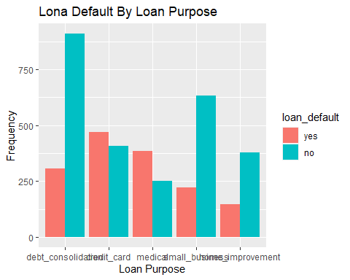

Figure 4

The results in figure 4 above shows that the loan default rate was associated with the purpose of the loan. The default rate was higher among those people who took the loan for credit card purposes, and medical expenses. The default rate was low among those who took the loan for debt consolidation, small business and home improvement.

## Question 5: What is the relationship between loan defaulting and loan purpose as well as loan amount?

## Summary dataframe showing Loan amount by Loan purpose and Loan default

plotdata <- loans_df %>%  
group_by(loan_default, loan_purpose) %>%  
summarize(mean_loan_amount = mean(loan_amount))

## `summarise()` has grouped output by 'loan_default'. You can override using the  
## `.groups` argument.

plotdata

## # A tibble: 10 × 3  
## # Groups: loan_default [2]  
## loan_default loan_purpose mean_loan_amount  
## <fct> <fct> <dbl>  
## 1 yes debt_consolidation 17704.  
## 2 yes credit_card 17076.  
## 3 yes medical 17058.  
## 4 yes small_business 18351.  
## 5 yes home_improvement 17755.  
## 6 no debt_consolidation 16224.  
## 7 no credit_card 16173.  
## 8 no medical 16635.  
## 9 no small_business 16116.  
## 10 no home_improvement 16330.

## Bar graph showing Loan default based on Loan amount and Loan purpose

ggplot(plotdata,  
aes(x = loan_purpose,  
y = mean_loan_amount)) +  
geom_bar(stat = "identity", fill="blue")+  
 labs(title = "Loan default based on Loan amount and Loan purpose")+  
 facet_wrap(~loan_default) +  
 coord_flip()

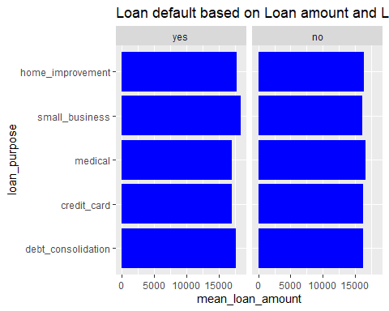

Figure 5

The results from Figure 5 above indicate that the rate of default was lower among individuals who took a loan of a larger amount (M =16224) for debt consolidation compared to those who took a loan of a lower amount (M = 17704) for debt consolidation. The loan amount had a bigger influence on whether a person defaulted on loan payments for individuals who took the loan for small business purposes. Individuals who took a bigger loan for small businesses were more likely to default on payment. The amount of loan taken did not have a bigger impact on whether a person defaulted on loan payments or not for loans taken for medical purposes.

# Predictive analysis

In this section, we fitted two classification algorithms (logit model and Linear Discriminant Analysis (LDA) model) to predict the response variable, loan_default. This study used all of the other variables in the loans_df data as predictor variables for each model.

## Loading necessary libraries

# Load necessary libraries  
library(caret)

## Loading required package: lattice

##   
## Attaching package: 'caret'

## The following objects are masked from 'package:yardstick':  
##   
## precision, recall, sensitivity, specificity

## The following object is masked from 'package:purrr':  
##   
## lift

library(recipes)  
library(parsnip)  
library(yardstick)  
library(ROCR)  
library(caret)  
library(pROC)

## Type 'citation("pROC")' for a citation.

##   
## Attaching package: 'pROC'

## The following objects are masked from 'package:stats':  
##   
## cov, smooth, var

library(tidymodels)  
library(tidyverse)  
library(MASS)

##   
## Attaching package: 'MASS'

## The following object is masked from 'package:dplyr':  
##   
## select

Data splitting and feature engineering steps were only conducted once so that the models will be using the same data and feature engineering steps for training.

## Feature engineering

This study used normalization, scaling and one-hot encoding as prefered feature engineering techniques.

# Set a seed for reproducibility  
set.seed(123)  
  
# Step 1: Feature engineering on the original data  
loan_recipe <- recipe(loan_default ~ ., data = loans_df) %>%  
 # Scale numeric variables  
 step_scale(all_numeric()) %>%  
 # One-hot encode categorical variables  
 step_dummy(all_nominal())

## Splitting the dataset

# Split the data into a training and test set using caret  
set.seed(123)  
splitIndex <- createDataPartition(loans_df$loan_default, p = 0.7,   
 list = FALSE,   
 times = 1)  
train_data <- loans_df[splitIndex, ]  
test_data <- loans_df[-splitIndex, ]  
  
# Split the training data into 5 folds for 5-fold cross-validation  
cv_folds <- createFolds(train_data$loan_default, k = 5)

## Specifying parsnip model object

# Specify a parsnip model object (Logistic Regression)  
logit_model <- logistic_reg() %>%  
 set_engine("glm") %>%  
 set_mode("classification")

## Fitting the workflow and packaging the recipe

# Step 4: Package your recipe and model into a workflow for Logistic Regression  
workflow_logit <- workflow() %>%  
 add_recipe(loan_recipe) %>%  
 add_model(logit_model)  
  
# Step 5: Fit your workflow to the training data for Logistic Regression  
trained_workflow_logit <- train(  
 loan_default ~ .,   
 data = train_data,  
 method = "glm",  
 trControl = trainControl(method = "none", classProbs = TRUE), # Enable class probabilities  
 metric = "ROC"  
)

## Fitting a logit model

# Step 6: Get predicted probabilities for Logistic Regression  
test_predictions_logit <- predict(trained_workflow_logit, newdata = test_data, type = "prob")  
  
# Calculate ROC curve and AUC for Logistic Regression  
roc_logit <- roc(test_data$loan_default, test_predictions_logit$yes)

## Setting levels: control = yes, case = no

## Setting direction: controls > cases

roc_auc_logit <- auc(roc_logit)  
  
# Plot ROC curve  
plot(roc_logit, print.auc = TRUE, main="ROC of the logit model")

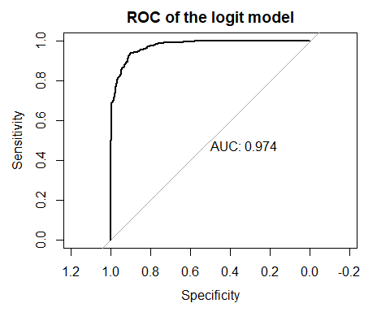

Figure 6.

The results from figure 6 above shows that the AUC for the logistic regression model was 0.974. This indicates that the logistic regression model has a stronger ability to differentiate between individuals who defaulted on loan payments and those who paid in full. The area under the curve 1 is closer to the maximum value of 1. This indicates that the model’s predictive ability is more accurate and can be relied upon.

## Fitting a LDA

# Create the LDA model  
lda_model <- lda(loan_default ~ ., data = train_data)  
  
# Fit workflow to the training data  
# No hyperparameter tuning needed for LDA  
trained_lda_model <- lda_model  
  
# Predict on the test data  
test_predictions_lda <- predict(trained_lda_model, newdata = test_data)  
  
# Create an ROC curve and calculate the AUC  
roc_lda <- roc(response = ifelse(test_data$loan_default == "yes", 1, 0), predictor = test_predictions_lda$x)

## Setting levels: control = 0, case = 1

## Warning in roc.default(response = ifelse(test_data$loan_default == "yes", :  
## Deprecated use a matrix as predictor. Unexpected results may be produced,  
## please pass a numeric vector.

## Setting direction: controls > cases

# Calculate the AUC (Area Under the Curve)  
roc_auc_lda <- auc(roc_lda)  
  
# Plot the ROC curve with the AUC value  
plot(roc_lda, print.auc=TRUE ,main = "ROC of the LDA model")

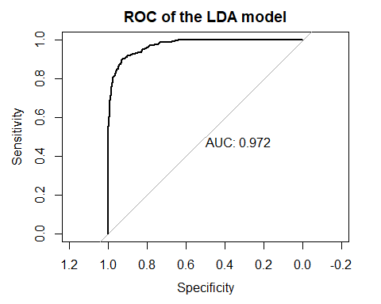

Figure 7.

The results from figure 7 above shows that the AUC for the Linear discriminant analysis (LDA) model was 0.972. This indicates that the Linear discriminant analysis regression model has a stronger ability to differentiate between individuals who defaulted on loan payments and non-defaulter. The area under the curve of 0.972 is closer to the maximum value of 1. This indicates that the model’s predictive ability is more accurate and can be relied upon but not better when compared to the logistic regression model.

## Model performance metric

# Predictions for Logistic Regression  
test_predictions_logit <- predict(trained_workflow_logit, test_data)  
  
# Confusion matrix for Logistic Regression  
confusion_logit <- confusionMatrix(data = test_predictions_logit, reference = test_data$loan_default)  
  
# Calculate confusion matrix for LDA model  
conf_matrix_lda <- table(Predicted = test_predictions_lda$class, Actual = test_data$loan_default)  
  
# Calculate accuracy for Logistic Regression  
accuracy_logit <- confusion_logit$overall['Accuracy']  
  
# Calculate accuracy for LDA  
accuracy_lda <- sum(diag(conf_matrix_lda)) / sum(conf_matrix_lda)  
  
# Calculate sensitivity (True Positive Rate) for Logistic Regression  
sensitivity_logit <- confusion_logit$byClass['Sensitivity']  
  
# Calculate sensitivity (True Positive Rate) for LDA  
actual <- test_data$loan_default  
predicted <- predict(trained_lda_model, newdata = test_data)$class  
  
TP <- sum(predicted == "yes" & actual == "yes")  
FN <- sum(predicted == "no" & actual == "yes")  
  
sensitivity_lda <- TP / (TP + FN)  
  
cat("Logistic Regression Accuracy:", accuracy_logit, "\n")

## Logistic Regression Accuracy: 0.918897

cat("LDA Accuracy:", accuracy_lda, "\n")

## LDA Accuracy: 0.9148418

cat("Logistic Regression Sensitivity:", sensitivity_logit, "\n")

## Logistic Regression Sensitivity: 0.8845316

cat("LDA Sensitivity:", sensitivity_lda, "\n")

## LDA Sensitivity: 0.8649237

The accuracy of the logistic regression model was 0.9189 with a sensitivity of 0.8845 while the accuracy of the Linear Discriminant model was 0.9148 with a sensitivity of 0.8649.

## Selecting the best model

# Selecting the best model  
if (roc_auc_lda > roc_auc_logit) {  
 best_model <- "LDA"  
} else {  
 best_model <- "Logistic Regression"  
}  
  
cat("The best model is:", best_model)

## The best model is: Logistic Regression

Best of the results above, the best model in the prediction of whether a person would default or not default on loan payment is a logit regression model since it had a better accuracy value compared to the LDA model.

# Summary of Results

Introduction

The company faces a critical challenge in reducing loan defaults while still sustaining steady growth and profitability. To address this problem the company aims to leverage data visualization and predictive analytics to determine the factors that are associated with defaulting on loan payments and whether it is possible to accurately predict whether a customer will eventually default on their loan. The findings and insights drawn from this project will be key in decision-making on lending, optimization of risks, and ensuring that there is long-term success in the lending sector. Business problem The primary challenge facing the company (bank) is the record number of customer defaulters experienced by the company over a couple of years and its leading financial losses. The bank is finding it difficult to effectively identify and mitigate the risk of loan defaulters. Solving this problem is essential in maintaining the financial stability of the bank and facilitating business growth. By accurately predicting the likelihood of a person defaulting on the loan payment, the bank will tailor its lending policies and practices to minimize financial loses and maximize profit.

Goal of the study

Logit and Linear discriminant analysis (LDA) approach

The development of the predictive model in this project involved the use of logistic regression and linear discriminant analysis (LDA) techniques. These were the most appropriate method as the dependent variable ‘loan default’ was recorded as binary (yes/no). This project also incorporated elements of the following research questions to determine the factors associated with loan defaulting: Is there a significant difference in the loan amount between borrowers who defaulted on their loans and those who did not?

Does the interest rate offered to borrowers have an impact on their likelihood of defaulting on loan payments?

Is there an association between the loan term and the likelihood of loan default?

Is there a significant relationship between defaulting on the loan and loan purpose?

What is the relationship between loan defaulting and loan purpose as well as loan amount?

These questions will highlight the factors that affect loan repayment which will inform the policies that can be implemented to minimize of defaults arising from those factors. The models will help in determining if it is possible to predict whether a customer will default on their loan and costly errors are the model expected to produce.

Findings

Explanatory Data Analysis

The results from the grouped bar chart on the relationship between loan amount and load defaulting showed that there was a difference in the loan amount between borrowers who defaulted on their loans and those who did not. The difference in the amount between those who defaulted and those who did not default was 1202.32 which is a huge difference. This result indicates that people who received more amount were more likely to default and thus the bank should either request huge collateral, develop better recovery measures or get more details from the customer which will make it hard for them to default.

The results from the boxplot showing the impact of interest rate on defaulting on loan payments showed that loans with a higher interest rate were defaulted the most compared to those with a lower interest rate. On average, loans with an interest rate of 14 attracted the most defaults. This result is important as it displays how the interest rates of the bank are affecting its profitability. Higher default rates from loans with higher interest rates are costing the bank big.

The results from the grouped bar chart showed that loan term and loan default were related. The data showed that loans with a higher term limit were at a higher risk of being defaulted. This finding is important as it helps the company set up more recovery measures and other policy measures on loan term loans that cost the bank more losses.

It was also evident that the loan purpose affected the rate at which people defaulted on the loan. Loans that were taken for medical and credit card purposes were defaulted the most. The amount of money taken did not affect the rate of defaulting on medical loans. The rate of default was higher among small businesses and for home improvement that took larger amounts of loans compared to those that took smaller amounts of loans.

Model results

The best classification model based on the results above was a logistic regression model. The logistic regression model had a higher AUC value of 0.974 compared to 0.972 for the linear discriminant analysis (LDA) model. The accuracy and sensitivity of logit model was also better than the linear discriminant analysis (LDA) model with the accuracy of the logistic regression model being 0.9189 with a sensitivity of 0.8845 while the accuracy of the linear discriminant analysis (LDA) model being 0.9148 with a sensitivity of 0.8649. The logistic regression model correctly predicted the outcome (loan default or non-default) in approximately 91.89% of cases. The Logit model correctly classified 88.45% of defaulters to have defaulted on loan payment which means that only 11.55% of the defaulters were wrongly classified to not have defaulted. The model performance threshold was good.

Recommendation

The results showed that interest rates affected the loan payment. I would recommend that the bank should lower their interest rate so that individuals can find it easier and cheaper to repay their loans. The bank should also use other methods other than higher interest rates on high-risk loans as the interest rate was even worsening the loan default situation. Lowering interest will most probably attract more customers, and attract fewer defaults thus improving the profitability. The bank should also consider giving out huge loans to individuals who display better repayment features like higher credit scores, more tangible collateral, steady job/business/income flow, and loan term to minimize default rates as the data showed that long-term loans were defaulted the most. I would recommend that more individual information be recorded for long-term loans which might help the bank trace them in case they fail to pay and the company should also attach more collateral options or guarantors who might make it easier for the bank to recover the money given out as a loan.  
I would also recommend that the bank provides more education and resources for borrowers taking long-term loans which will help them understand the financial commitment and the risk associated with the loans that they have taken.

Conclusion

In conclusion, the analysis of loan default in the bank has yielded important insights. The logistic regression tool selected from this study for future use in the banks for prediction has a higher accuracy of predicting whether a person will default or not on a loan payment and a higher sensitivity of classifying a customer as having defaulted when indeed they have defaulted. This prediction tool and the other findings should be used by the bank to guide their decision-making process to help them optimize the lending policies, minimize potential losses, and enhance risk management.